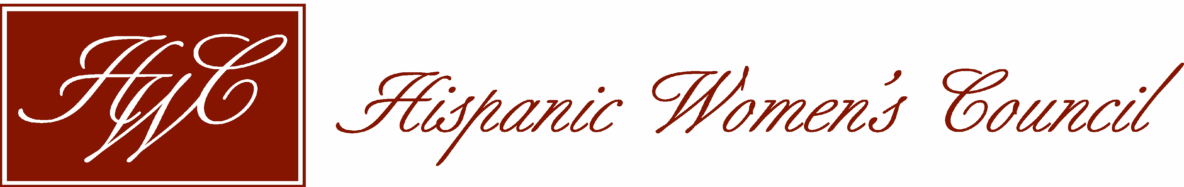
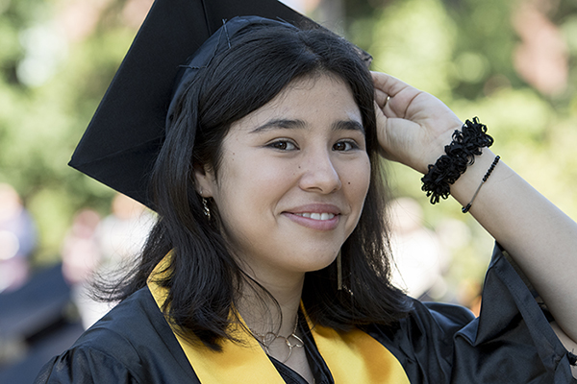
Hispanic Women’s Council Scholarship Committee
P.O. Box 27271
Albuquerque, NM 87125
www.nmhwc.com

HWC Announces its Current Scholarship Cycle
Complete Submission Packets must be emailed as one document to hispanicwomenscouncil@gmail.com AND lflores@unm.edu.
Application Deadline: July 1, 2023, 11:59 PM

The Hispanic Women's Council (HWC) Scholarship Program offers scholarships to help Hispanic Women who are working to COMPLETE degrees, licenses, or programs of study. The HWC Scholarship is intended for graduate level students or CONTINUING undergraduate students with 60+ university or community college hours (no high school dual-credits).

Applicants must be accepted and registered at the University of New Mexico (UNM) or Central New Mexico Community College (CNM) at the time of application. Applicants who will not be attending UNM or CNM will not considered for this scholarship.

- New applicants, please use “NEW” scholarship application (information sheet; application form and all requested documents; letters of reference).
- Prior scholarship recipients, please use “RENEWAL” scholarship application (application form and all requested documents) if you attended HWC Mentoring in 2022-2023.

All application information is included in the documents on the HWC website www.nmhwc.com . You will need to download forms, fill them out, cut and paste them together into ONE DOCUMENT (PDF or .docx), and submit via email to hispanicwomenscouncil@gmail.com AND lflores@unm.edu by the required date.

Be sure that all forms in your file or document include your first initial, last name and title of the form: (For example, if your name were Laura Cantu, here is how you would title the application document you are sending in: “LCantuHWCApplication2023”

Again: All application forms should be submitted to hispanicwomenscouncil@gmail.com and lflores@unm.edu in one email message. Reference forms can be submitted by the applicant or the person who is writing the reference can send them directly to hispanicwomenscouncil@gmail.com AND lflores@unm.edu with your name and HWC in the title.

NOTE: Incomplete submissions will not be accepted.

Please download the application forms, and email according to instructions provided.

About the HWC Scholarship
The New Mexico Hispanic Women’s Council is a 501(c)(3) non-profit, intergenerational organization founded in 1988 to promote, support, and create opportunities for Hispanic women. The HWC Scholarship Program is established to provide academic scholarships that range from $500 to $1000/year (dispersed in two payments in fall and spring, no exceptions) and mentorship to qualifying Hispanic women who are residents of New Mexico. It is available to CONTINUING college students (traditional and non-traditional). With these scholarships, the HWC envisions creating a legacy of:

a) Educating Hispanic women;
b) Moving them into professions; and,
c) Enabling them to become valuable leaders in our community.

NOTE: The MENTORING component of the scholarship is perhaps the most important part of this award and it requires meeting a minimum of once per year with a mentor for academic and career advising –an opportunity that has proven to be invaluable to most recipients. Scholarships are awarded on the basis of the strength of the applicant’s file. Successful awardees who complete all requirements will be considered for renewal.

Questions? Please email Dr. Leila Flores-Dueñas at lflores@unm.edu or text/call (505) 688-0839.

